Assessment Schedule – 2015
Physics: Demonstrate understanding of aspects of wave behaviour (90938)
Assessment Criteria
Achievement | Achievement with Merit | Achievement with Excellence
Demonstrate understanding of aspects of wave behaviour involves:  Demonstrating awareness of sound wave propagation and properties of sound waves. | Demonstrate in-depth understanding of aspects of wave behaviour involves:  Showing how sound wave propagation relates to particle motion and to the properties of the sound wave. | Demonstrate comprehensive understanding of aspects of wave behaviour involves:  Providing evidence that shows how concepts of wave properties and wave propagation relate to the situation of echolocation.
Evidence
Q | Achievement | Achievement with Merit | Achievement with Excellence
ONE  (a)(i) | Longitudinal wave.  OR | Longitudinal wave.  AND
(ii) | 2 wavelengths.  OR  Defines a wavelength / explains using diagram. | 2 wavelengths, because the wavelength is the distance between one compression to the next compression / repeating pattern.
(b) | Particles move parallel/in the same direction as wave movement. | Particles move back and forth / vibrate / oscillate in the same direction/parallel to wave motion.
(c) | Calculates a period using frequency of 150 Hz to get answer of 0.0067.  OR  Use of T 1/150 000 but left as fraction.  OR  Incorrect rounding of 6.7 × 10^{–6}  OR  T = 6.7 × 10^{–6} but missing / incorrect unit. | 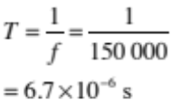

(d)(i) | (Correctly calculates:  v_{seawater} = 4.5 × 343 = 1543.5 (m s^{–1}))  Calculates a distance without halving (time or distance):  E.g. d = 1543.5 × 0.060  = 92.61  OR  d = v × t  = 343 × 0.060  = 20.6  OR  Correct calculation (halving time or distance) but incorrect answer  OR | (Correctly calculates :  v_{seawater} = 4.5 × 343 = 1543.5 (m s^{–1}))  Correct calculation (halving time or distance), correct answer but missing/incorrect unit  2d = 1543.5 × 0.060  = 92.61 m  d = 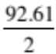  = 46.3 (46)  OR | (Correctly calculates :  v_{seawater} = 4.5 × 343 = 1543.5 (m s^{–1}))  Correct calculation (halving time or distance), correct answer, correct unit  2d = 1543.5 × 0.060  = 92.61 m  d =  = 46.3 (46) m  AND
(ii) | An echo from a near object arrives earlier/in a shorter time/quicker/faster than that from a distant object. | (Since the velocity of sound in water remains constant) an echo from a near object arrives earlier / in a shorter time (not “quicker”) than that from a distant object.  The dolphin uses the time delay to distinguish between the near object and the distant object. | E7: (Since the velocity of sound in water remains constant) an echo from a near object arrives earlier/in a shorter time (not “quicker”) than that from a distant object.  E8: The dolphin uses the time delay to distinguish between the near object and the distant object.

NØ | N1 | N2 | A3 | A4 | M5 | M6 | E7 | E8
No response; no relevant evidence. | Very little Achievement evidence. | Some evidence at the Achievement level; partial explanations. | Most evidence is at the Achievement level. | Nearly all the evidence is at the Achievement level. | Some evidence is at the Merit level with the remainder at the Achievement level. | Most evidence is at the Merit level with some at the Achievement level. | Evidence is provided for most tasks with evidence at the Excellence level weak or incomplete. | Evidence is provided for most tasks with evidence at the Excellence level accurate and full.
As above. | 1a | 2a | 3a  OR  1e + 1a  OR  1m + 1a | 4a | 2m  OR  1e + 2a  OR  1e + 1m | 3m | 1a + 1m  AND  1(d) is correct | 1a + 1m  AND  1(d) is correct including how dolphin uses the time delay

Q | Achievement | Achievement with Merit | Achievement with Excellence
TWO  (a) | Diagram showing diffraction of waves with at least 3 wave fronts shown but wavelength not kept the same/curve not precise. | Correct diagram showing diffraction of waves with at least 3 wave fronts shown with no change in wavelength.  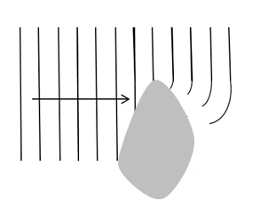
(b) | Diffraction.
(c)(i) | Calculated the wavelength correctly.  OR | (i) Correct wavelength calculation.  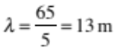
(ii) | Calculated the speed using wrong wavelength from (i).  OR  Correct calculation of speed but missing/incorrect unit | v = f λ  = 0.25 × 13  = 3.25 (3.3) m s^{–1}

(d)(i) | Any ONE of the following:  Both of:  - Angle of incidence  = 90° – 55° = 35°  - Angle of reflection is equal to angle of incidence.  OR | Any TWO of the following:  Both of:  - Angle of incidence  = 90° – 55° = 35°  - Angle of reflection is equal to angle of incidence.  OR | E7:  - Angle of incidence is  = 90° – 55° = 35°  - Angle of reflection is equal to angle of incidence.  AND
 | 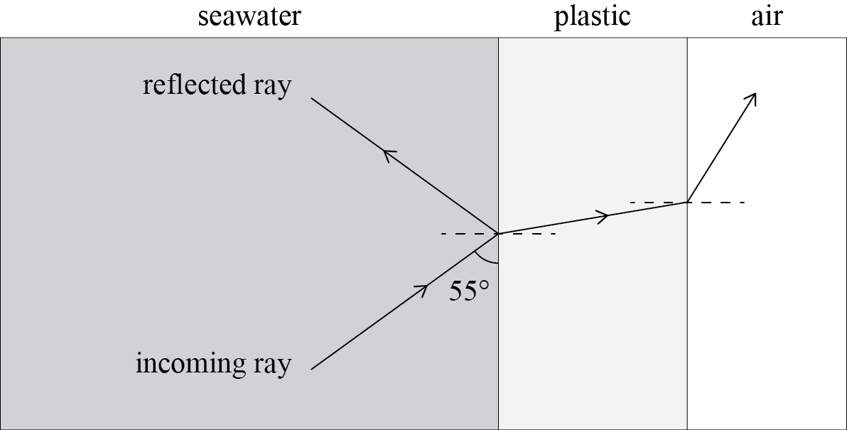  Both of:  - Ray bends towards normal when going from seawater to plastic  - Ray bends away from normal when going from plastic to air  OR | Both of:  - Ray bends towards normal when going from seawater to plastic  - Ray bends away from normal when going from plastic to air  (Correct arrows drawn on rays)  OR | AND:  - Ray bends towards normal when going from seawater to plastic  - Ray bends away from normal when going from plastic to air  (Correct arrows drawn on rays)  AND
 | - States that reflected ray has the same speed as the incoming ray. | - States that reflected ray has the same speed as the incoming ray because both waves travelling in the same medium. (Reflection does not cause a change in speed.) | - States that reflected ray has the same speed as the incoming ray because both waves travelling in the same medium. (Reflection does not cause a change in speed.)  E8:  Plus states / implies Angle of incidence is measured from the normal.  AND  (Ray bends more away from normal compared to amount it bends towards normal from seawater to plastic.)

NØ | N1 | N2 | A3 | A4 | M5 | M6 | E7 | E8
No response; no relevant evidence. | Very little Achievement evidence. | Some evidence at the Achievement level; partial explanations. | Most evidence is at the Achievement level. | Nearly all the evidence is at the Achievement level. | Some evidence is at the Merit level with the remainder at the Achievement level. | Most evidence is at the Merit level with some at the Achievement level. | Evidence is provided for most tasks with evidence at the Excellence level weak or incomplete. | Evidence is provided for most tasks with evidence at the Excellence level accurate and full.
As above. | 1a | 2a | 3a  OR  1e + 1a  OR  1m + 1a | 4a | 2m  OR  1e + 2a  OR  1e + 1m | 3m | 1a + 1m  AND  2(d) is correct | 1a + 1m  AND  2(d) is correct including explanation of angle of incidence measured from normal and ray bends away more from plastic to air compared to bending towards normal from seawater to plastic

Q | Achievement | Achievement with Merit | Achievement with Excellence
THREE  (a) | One correct ray drawn, 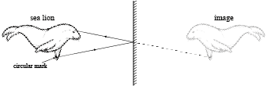  Or a correct ray diagram with two rays drawn but missing arrows, or no dotted lines for the virtual rays. | 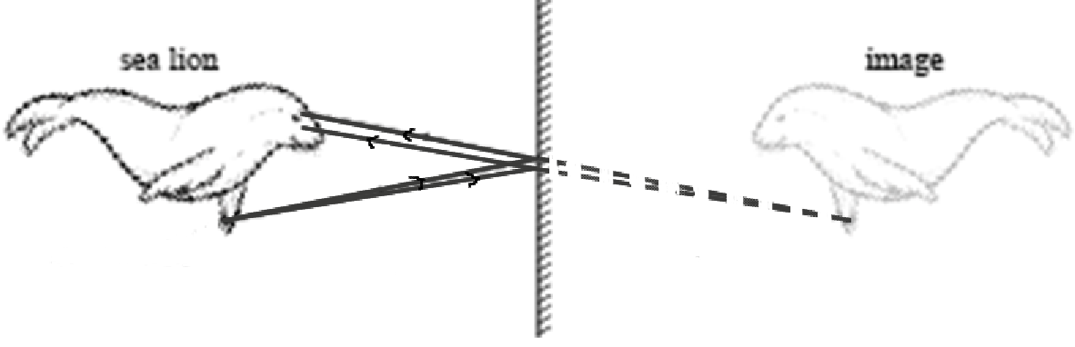  Correct ray diagram drawn, including arrows and dotted lines for the virtual rays.
(b) | A real image can be captured on a screen OR a real image is formed when real rays meet. A virtual image cannot be captured on a screen.  OR  Virtual image has diverging rays and a real image has converging rays
(c) | States ONE of the conditions:  - Light must travel from an optically denser medium towards an optically less dense medium.  - Light is incident at the interface at an angle greater than the critical angle. | States BOTH conditions:  - Light must travel from water to air. / Light must travel from an optically denser medium towards an optically less dense medium.  - The incident light must strike the (water-air) interface at an angle greater than the critical angle.

(d)(i) | Correctly calculates f:  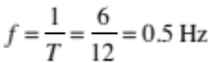  OR  Correctly calculates v:  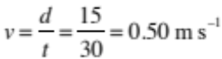  OR  Correct calculation of wavelength, λ = 1 but missing/incorrect units  OR | Correctly calculates λ 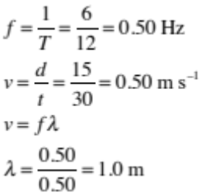  (Correct units required for λ)  OR | Correctly calculates λ  (Correct units required for λ)  AND
(ii) | Wavelength decreases / halves. | Since v = f λ, doubling the frequency halves the wavelength  AND because velocity remains constant. | E7: Since v = f λ, doubling the frequency halves the wavelength  E8: AND because velocity remains constant.
 |  | OR  If frequency is doubled the number of waves produced per second are doubled so the wavelength will halve AND frequency is the number of waves per second. | OR  E7: If frequency is doubled the number of waves produced per second are doubled so the wavelength will halve.  E8: AND frequency is the number of waves per second.

NØ | N1 | N2 | A3 | A4 | M5 | M6 | E7 | E8
No response; no relevant evidence. | Very little Achievement evidence. | Some evidence at the Achievement level; partial explanations. | Most evidence is at the Achievement level. | Nearly all the evidence is at the Achievement level. | Some evidence is at the Merit level with the remainder at the Achievement level. | Most evidence is at the Merit level with some at the Achievement level. | Evidence is provided for most tasks with evidence at the Excellence level weak or incomplete. | Evidence is provided for most tasks with evidence at the Excellence level accurate and full.
As above. | 1a | 2a | 3a  OR  1e + 1a  OR  1m + 1a | 4a | 2m  OR  1e + 2a  OR  1e + 1m | 3m | 1a + 1m  AND  3(d) is correct | 1a + 1m  AND  3(d) is correct including explanation that velocity remains constant and reference to  v = f λ,

Cut Scores
Not Achieved | Achievement | Achievement with Merit | Achievement with Excellence
0 – 6 | 7 – 12 | 13 – 19 | 20 – 24

